Student number : ST10489610

Name: Miguel ian Masinga

BIT

WEB DEVELOPMENT POE PART 1

Lecturer: Mr Vilakazi

**Table of Contents**

Website Development Proposal for Elegant Scents – Perfume and Cologne Company 3

Organisation overview 3

• Client Name: 3

Mission statement 3

Vision 3

Target audience 3

Website Goals and Objectives 3

Website Features and Functionality 4

Design and User Experience 4

Technical Requirements 4

Images Used 5

Timeline and Milestones 8

Budget 8

Hosting and maintenance 8

References 8

# Website Development Proposal for Elegant Scents – Perfume and Cologne Company

## Organisation overview

* Client Name: Elegant Scents
* Elegant Scents is a South African Based fragrance shop that is only focused on selling

Colognes, Perfumes and Perfume oils. It is located in Mpumalanga, Nelspruit. But can ship their products anywhere in South Africa.

### Mission statement

Elegant Scents aims to ensure that everyone smells good and feels confident every season of the year and at a very affordable price.

### Vision

Elegant Scents intends to have at least one store in each and every province in South Africa in the next 7 years to ensure that more people smell great and have a higher self esteem at a very affordable price.

### Target audience

Elegant scents targets individuals between the ages of 20-50 years of age, who just want to smell good when going to school, work or just going about their day

## Website Goals and Objectives

The primary goals and objectives of the website are to

* **Increase Online Sale**.

Increased online sales will lead to an increased revenue so that the organization can grow and expand at a faster rate.

* **Responsive Design**.

The design must not be laggy and unresponsive because customers will lose interest, instead it must be fast and efficient for customers to be interested in wanting to order from it.

* **Inform Customers**.

Website must be very informative so that customers will know what they are buying.

## Website Features and Functionality

The Elegant Scents website has the following features:

#### Home page

Consists of a very colourful design that is also topped with high quality pictures of newly featured products in order to grab the customers attention at first glance.

#### About Us

Contains background information about the company as a whole, like when and where it was established and where the physical store is located.

#### Products

Contains high quality images of some of the products sold on the website including their names and prices.

#### Contact

Contains directions to the physical store and various ways to get in touch with the company, whether to buy or if you want any additional information.

#### Enquiries

Contains information on what to do if you have want to be part of the Elegant Scents team and be a reseller or promoter of the products.

## Design and User Experience

* Colour scheme**:**

A simple black, white, red, blue and gray colour scheme. It is very interesting and attractive without being too harsh on the eye.

* Product images:

Extremely high quality, professional photos of the products which are very clear to see on any device.

## Technical Requirements

The website is created using visual studio code and the programming language used is HTML and for styling CSS was used. It requires maintenance by a qualified web developer and I am available for that.

## Images Used

(Harsh Limbachia**,** 2021)

(Mareefe, 2018)

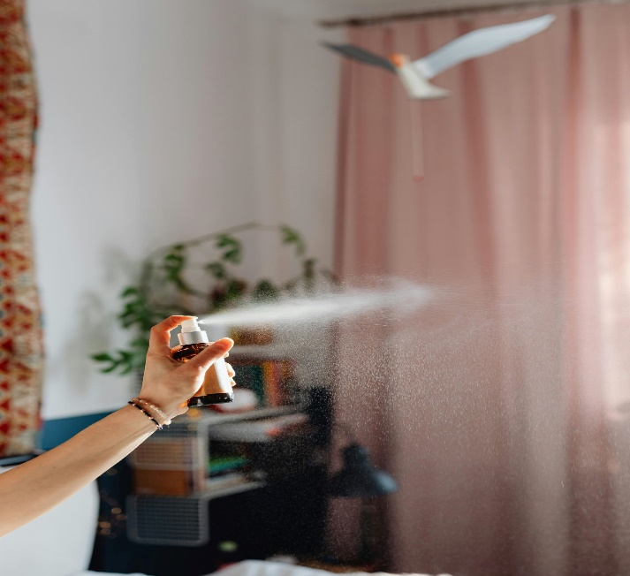

(Kaboompics, 2021)



(Castorly Stock, 2020)

(Arslan, 2020)

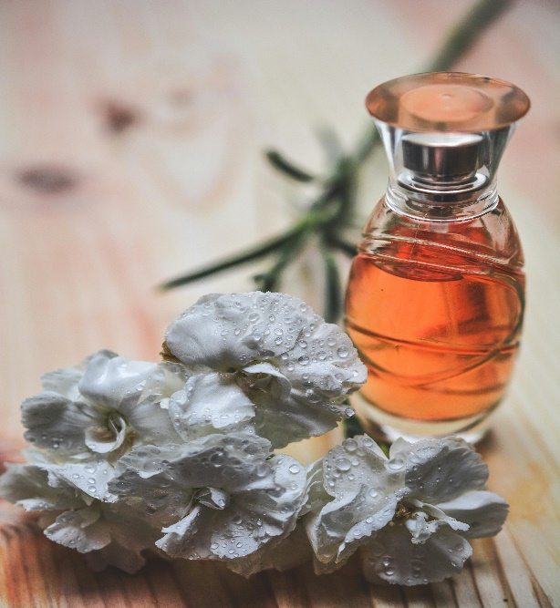

(Pixabay, 2016)

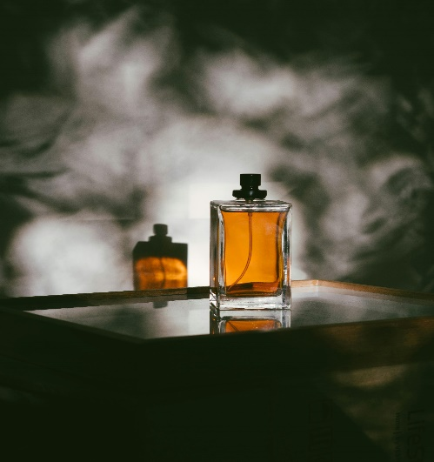

(RF Studio, 2019)

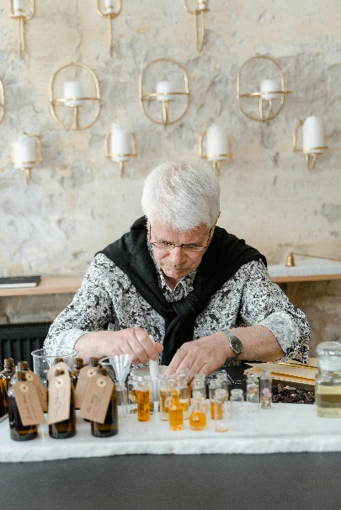

(Mart production, 2021)

## Timeline and Milestones

* Discovery and planning: 1 week
* Initial consultation and design approval: 1 week
* Website Development (backend and front end): 3 weeks
* Testing and Quality Assurance: 1 week
* Launch : 2 days

Total Estimated Time : 6-7 weeks

## Budget

* Basic Website (information and shop) :R15000

OPTIONAL ADD-ONS

* Professional product photography: R3500
* Monthly maintenance: R1500/month

## Hosting and maintenance

* Hosting will be via Afrihost
* Weekly backups and updates
* Firewall setup

## References

* Limbachia, H. (2021). Bulgari perfume bottle [photograph]. Available at: <https://images.pexels.com/photos/11577068/pexels-photo-11577068.jpeg?auto=compress&cs=tinysrgb&w=600>
* Mareefe. (2018). Perfume oil [photograph]. Available at: <https://images.pexels.com/photos/932577/pexels-photo-932577.jpeg?auto=compress&cs=tinysrgb&w=600>
* Kaboompics. (2021). Spraying perfume [photograph]. Available at: <https://images.pexels.com/photos/6633526/pexels-photo-6633526.jpeg?auto=compress&cs=tinysrgb&w=600>
* Castorly Stock. (2020). Grey perfume bottle [photograph]. Available at: <https://images.pexels.com/photos/3785784/pexels-photo-3785784.jpeg?auto=compress&cs=tinysrgb&w=600>
* Arslan, Y. (2020). Light blue perfume bottle [ photograph]. Available at: <https://images.pexels.com/photos/3640668/pexels-photo-3640668.jpeg?auto=compress&cs=tinysrgb&w=600>
* Pixabay. (2016). Rose gold perfume bottle [photograph] <https://images.pexels.com/photos/264950/pexels-photo-264950.jpeg?auto=compress&cs=tinysrgb&w=600>
* RF Studio. (2019). Gold perfume bottle [photograph]. Available at: <https://images.pexels.com/photos/3059609/pexels-photo-3059609.jpeg?auto=compress&cs=tinysrgb&w=1260&h=750&dpr=2>
* Mart production. (2021). Creating perfumes [photograph]. Available at: https://www.pexels.com/photo/a-man-holding-a-dropper-8450119/